

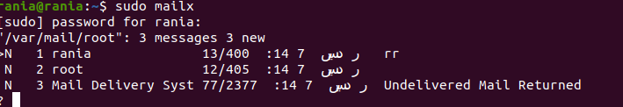



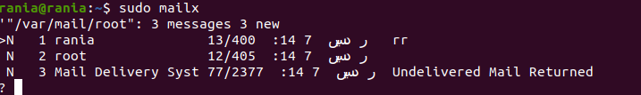

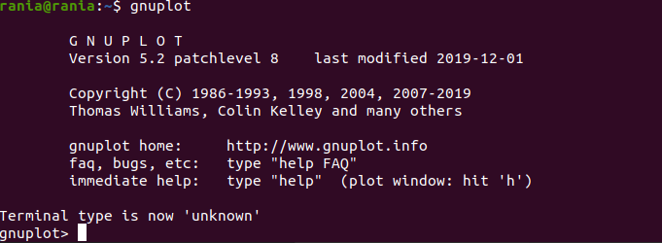

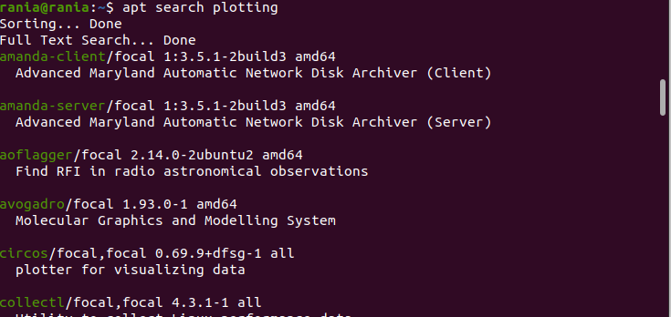





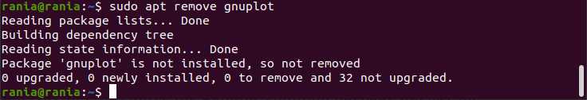



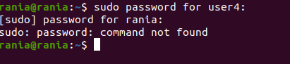

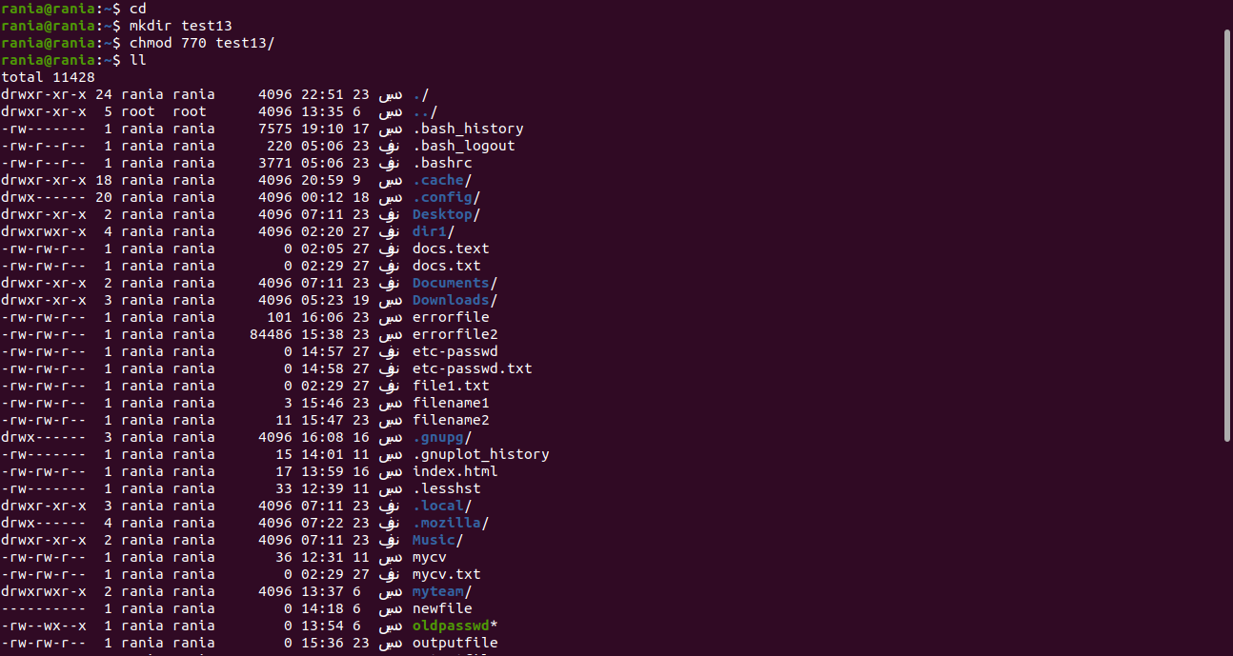

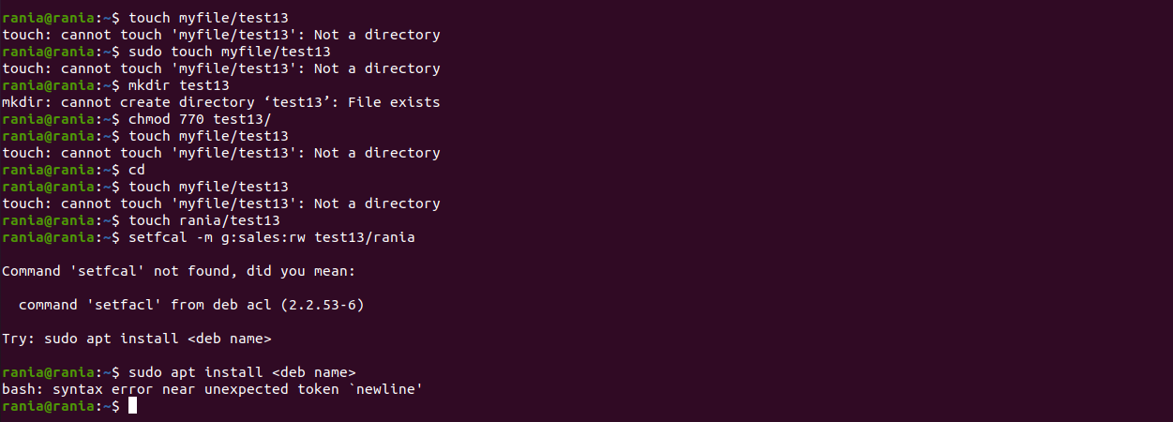

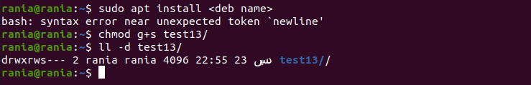

16. Grand your colleagues a collective directory called /opt/research, where they can store generated research results. Only members of group profs and grads should be able to create new files in the directory, and new file should have the following properties:

setfacl -m g:profs:wx ~/opt/research/

setfacl -m g:grads:wx ~/opt/research/

• the directory should be owned by root

sudo chown root:grads ~/opt/research/

• new files should be group owned by group grads

sudo chmod g+s ~/opt/research/

• group profs should automatically have read/write access to new files

done by default

• group interns should automatically have read only access to new files

sudo setfacl -m d:g:interns:r ~/opt/research/

• other users should not be able to access the directory and its contents at all.

sudo setfacl -m o:--- ~/opt/research/